### MONITORING INCIDENT STATES FOR EFFECTIVE MANAGEMENT

**Implementation**

**Activity-1:**

1. Open service now developer Instance
2. Click on All
3. Search for reports and click on create new  
   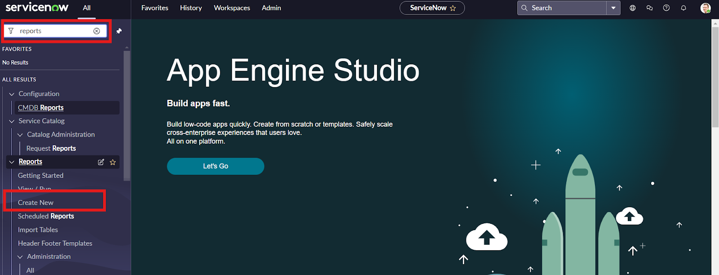
4. Give the report name
5. Select source type as table
6. Select table incident  
   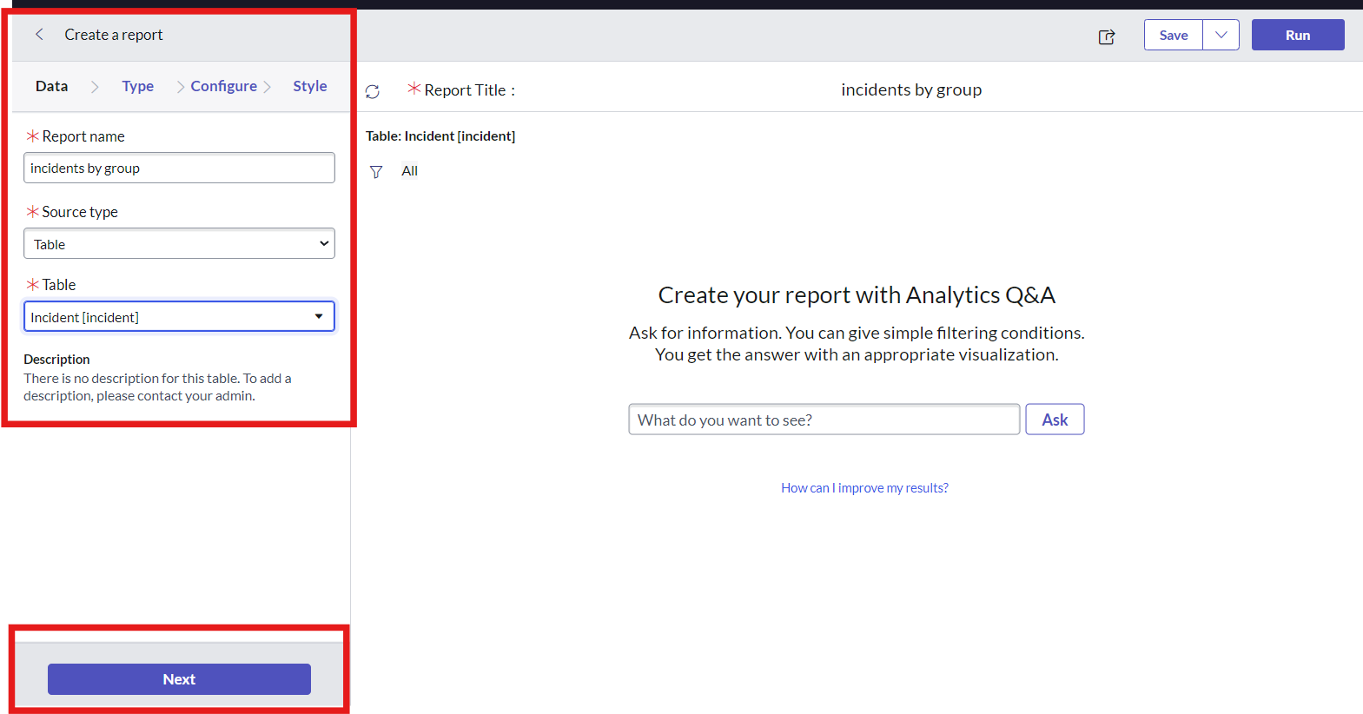
7. Click on next
8. Select type as pie chart
9. Click on funnel icon and give condition  
   Field : state  
   Operator : isoneof  
   Value : new,onhold,inprogress  
   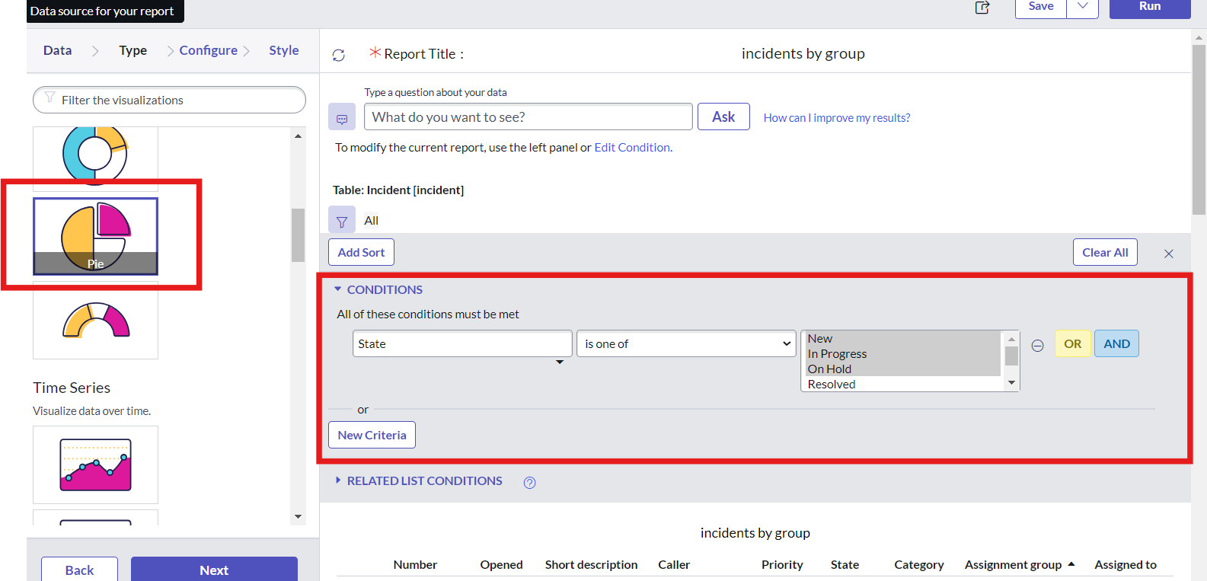
10. Click on next
11. Group by assignment group and click on next  
    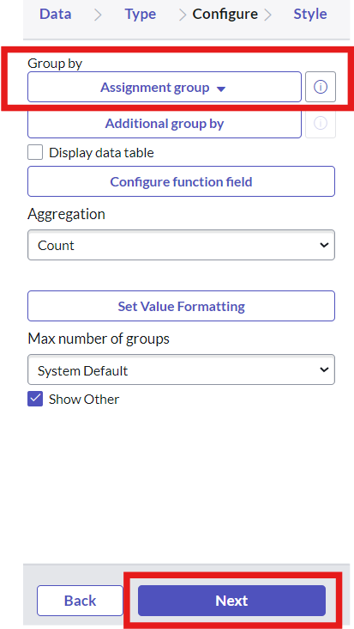
12. Click on save
13. Click on run  
    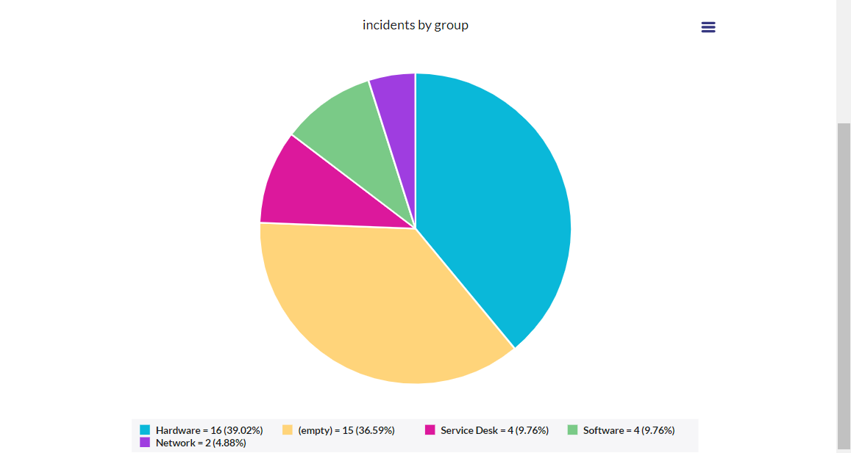
14. Now add report to dashboard  
    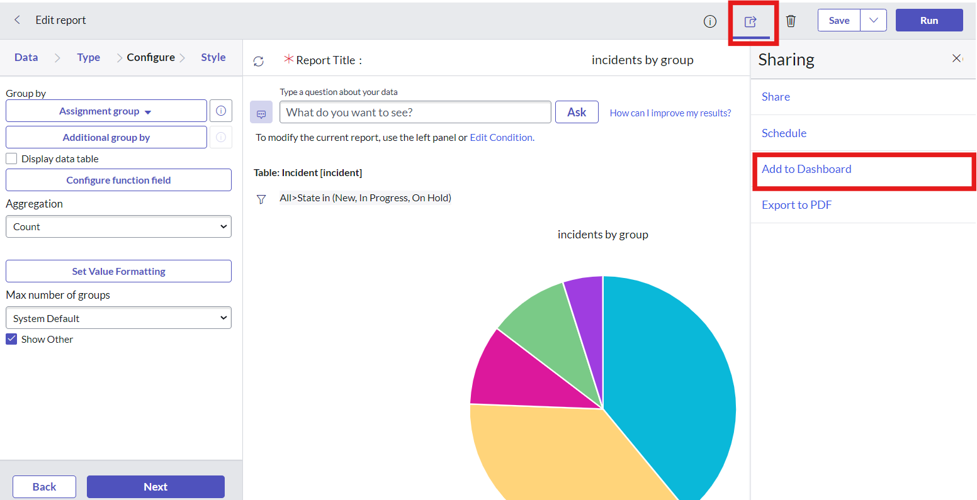
15. Give the dashboard and title name   
    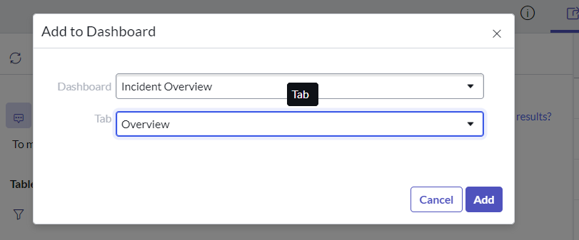
16. Click on add
17. New Dashboard was added to the incident overview folder

**Result:**

1. Open service now PDI instance
2. Click on all
3. Search for dashboard
4. Select dashboard under self service  
   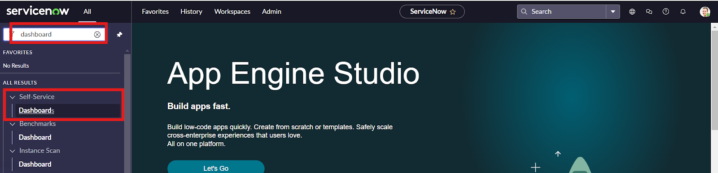
5. In the search bar enter incident
6. Select incident overview  
   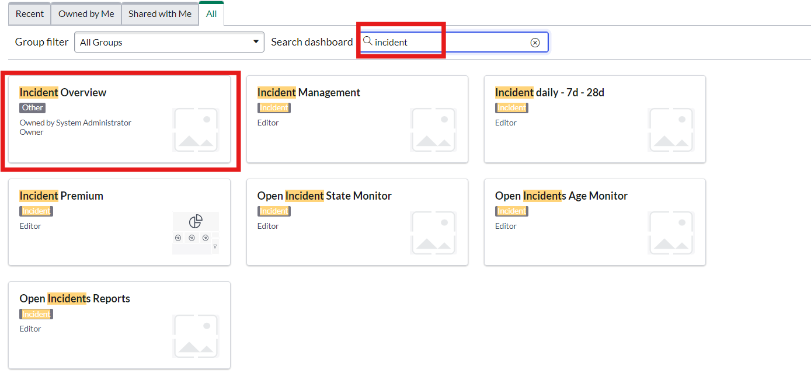

Here we can access the dashboard we create  
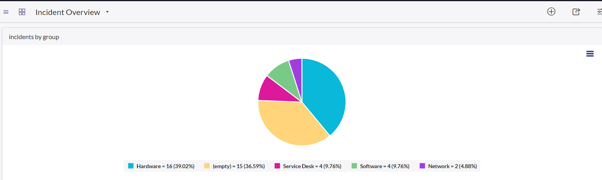

My Output:

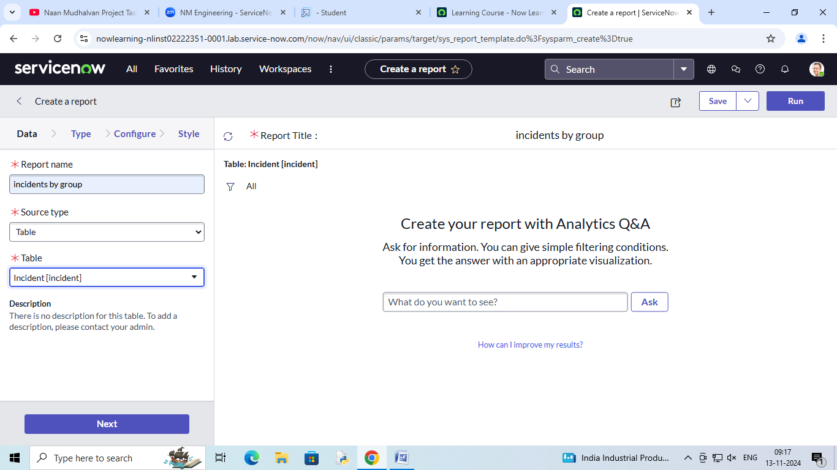

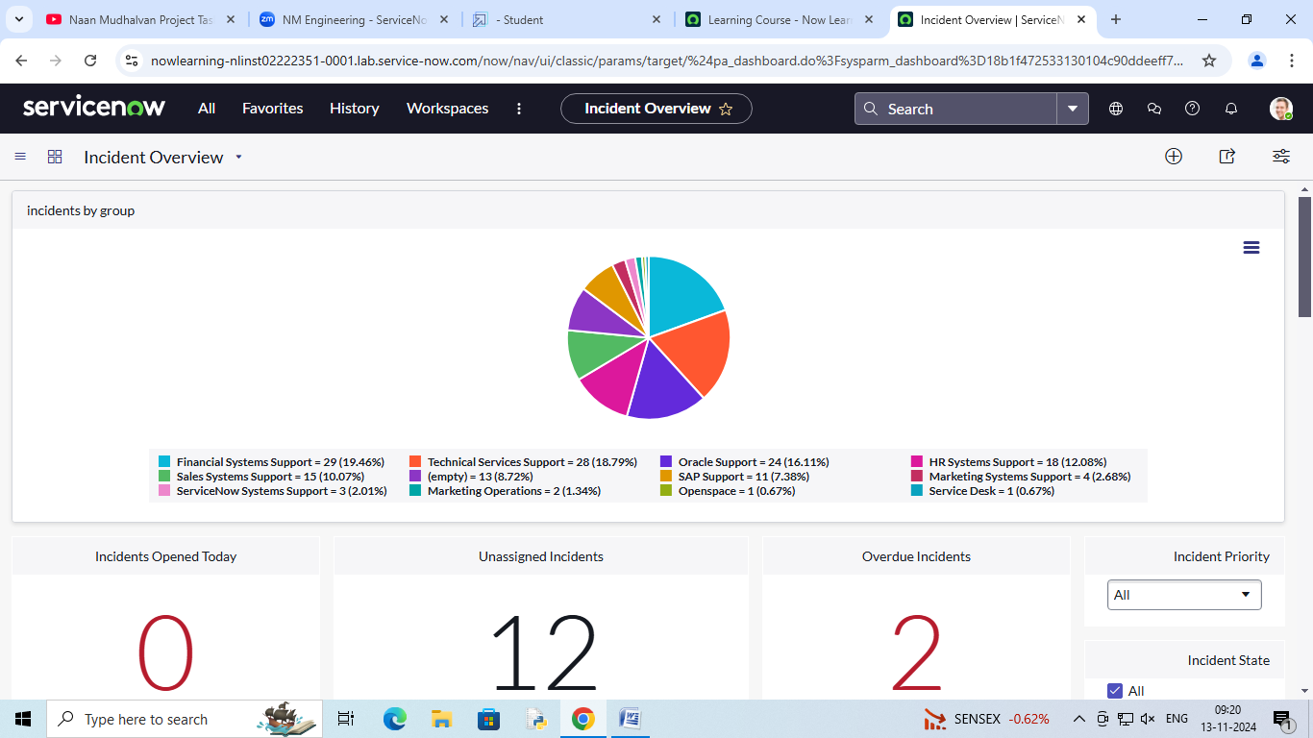

TEAM MEMBERS

MOHAMMED SHAMSAD.KK

AFSAL.PN

MOHAMMED NIBRAS HAMEED

MUHAMMED SHAFNAD.A